**Assignment 1. Excel Homework, Kickstart My Chart**

**Question 1, Given the provided data, what are three conclusions we can draw about the Kickstarter campaigns?**

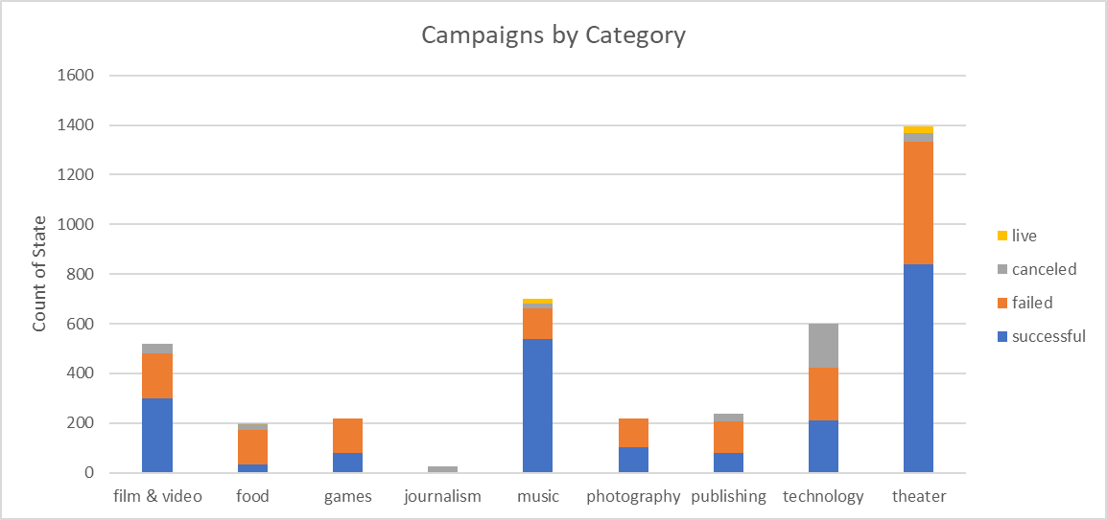

Based on the initial chart we created, the top four categoris for Kickstarter programs are 1) theater, 2) music 3) technology and 4) film & video. Of the top four categories, theater has the most successful attempts, but music, followed by film &video have the highest success rates as a percent of attempts. Technology is kind of interesting because it is almost equally divided between cancelled, failed and succesful.

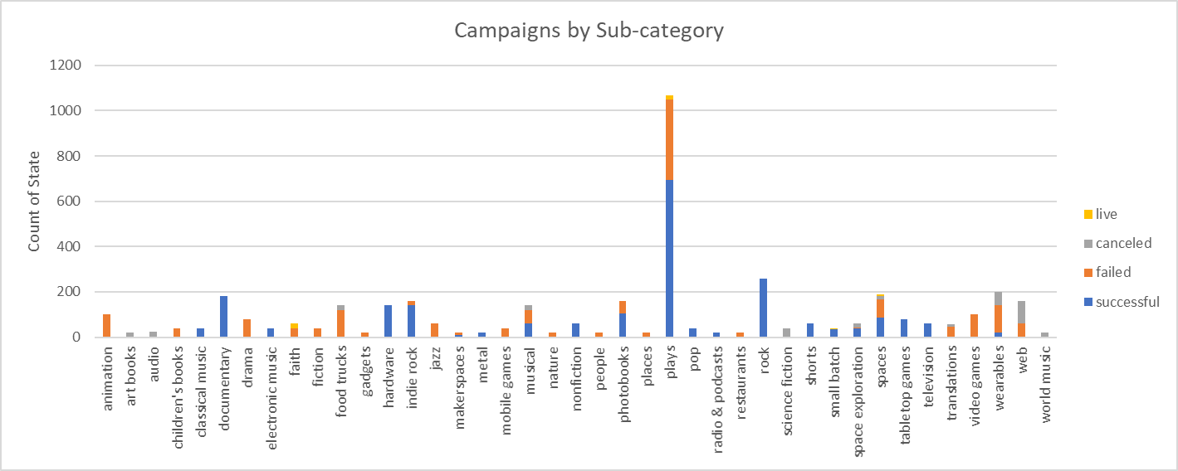

This deeper dive into the sub-categories, shows that within the theater category, plays account for the greatest number of attempts and by just eyeballing the data have between a 60%-70% success rate. Within the music category, rock is the largest sub-category and has a 100% success rate.

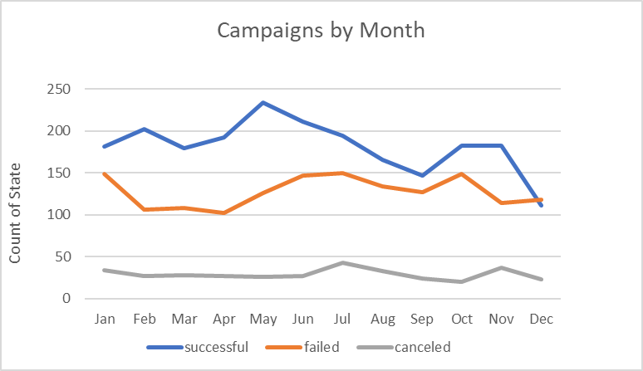

What I found to be most notable about this chart is that overall, the attempts had a higher success rate than failure or cancellation rate.

**Question 2, What are some limitations of this dataset?**

1. It would be helpful to have at least a second level of sub-category in many of the sub-categories. One example, in plays, breaking it into types of plays – comedies, dramas, biography, other. A second example, rock – hard rock, soft rock, rockabilly (not even sure what that is), other. This may better define what is included in the sample and success rates of the sub-sub-category.
2. Success appears to be based on whether the pledge is greater than or equal to the goal. First, the goal could be subjective where one campaign has low expectations and another campaign has very aggressive expectations. Second, if the pledge falls even $1 short of the goal, the campaign is classified as a failure.
3. Currency is in country of origin. This means that any data comparisons may be skewed from country to country. In order to compare data apples to apples it would need to be converted to one currency.

**Question 3, What are some other possible tables and/or graphs that we could create?**

If I were planning a campaign, and since I am based in the US, I would limit my analysis to US campaigns. I have done this in my data set.

I would determine if there are any benefits to being a Staff Pick.

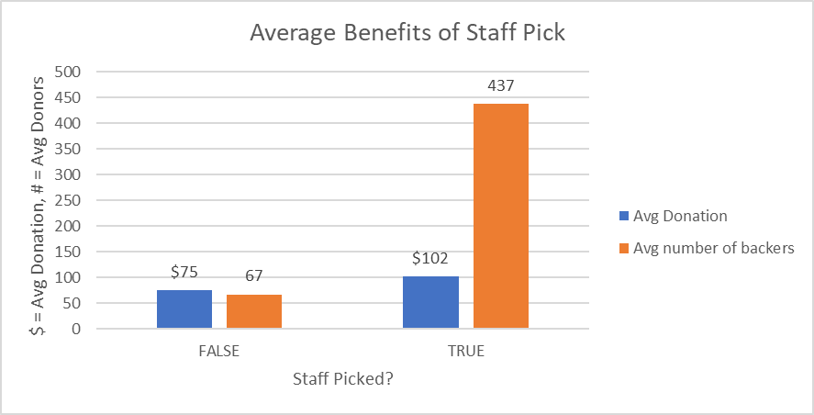

Based on the results, it appears that there is a the average donation and the average number of backers are in fact greater if the campaign is staff picked. Accordingly, I would determine what is necessary to get my campaign staff picked.

In the Campaigns by Category and Sub-Category chart above, they were for all countries. I would be interested to see if you get same results for just the US.

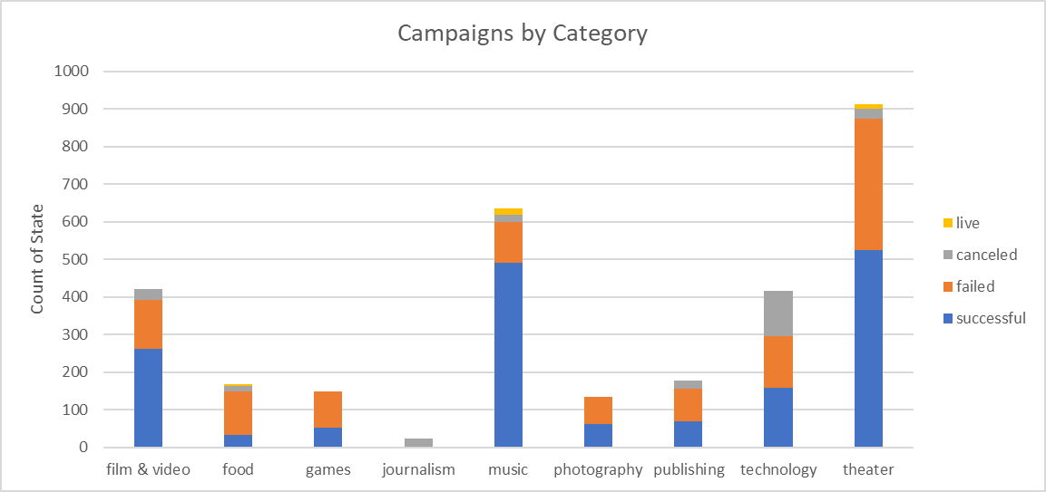

The top four categories remain 1) theater, 2) music, 3) film & video and 4) technology.

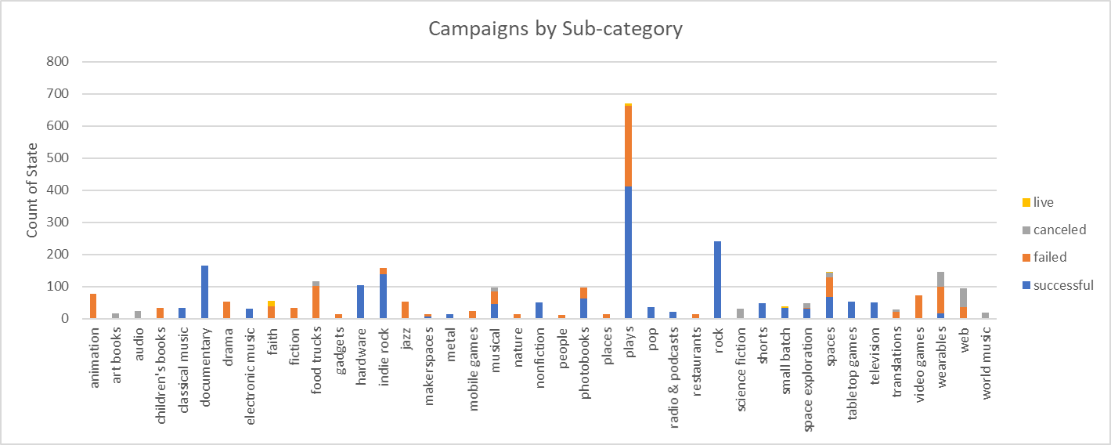

Similarly, the top two sub-categories are 1) plays and 2) rock

While it is clear that 100% of the rock campaigns are successful, a pie chart of the success rate on plays shows that 66% of the play campaigns are successful. Note that I did this for the last five years, excluding 2017 since 2017 was a partial year.

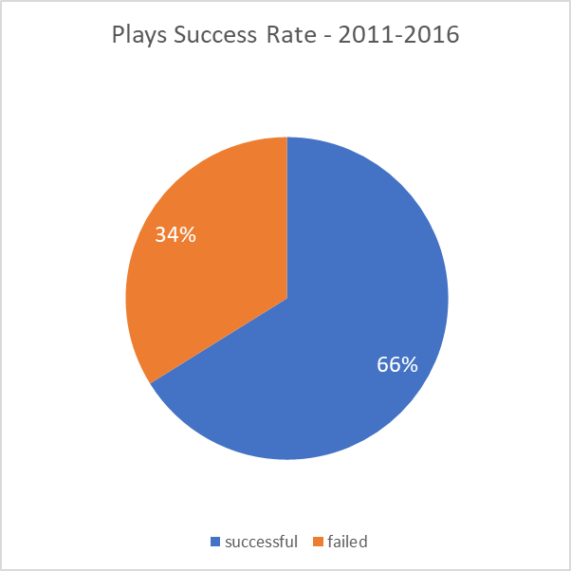

**Bonus 1**



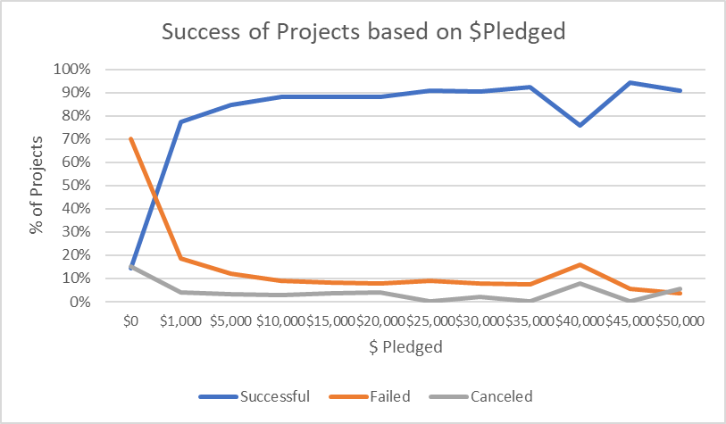

**Bonus 2**



**Does the Mean or the Median summarize the data more meaningful?**

Based on the Based on the relatively high standard deviation, sample variance, range and maximum and the comparatively low median, the median better summarizes the data.

**Is there more variability with success or unsuccessful campaigns?**

Based on the standard deviation, sample variance, range, minimum and maximum of both the successful and failed campaigns, there is more variability with the successful campaigns compared to the failed campaigns.